Adobe forms

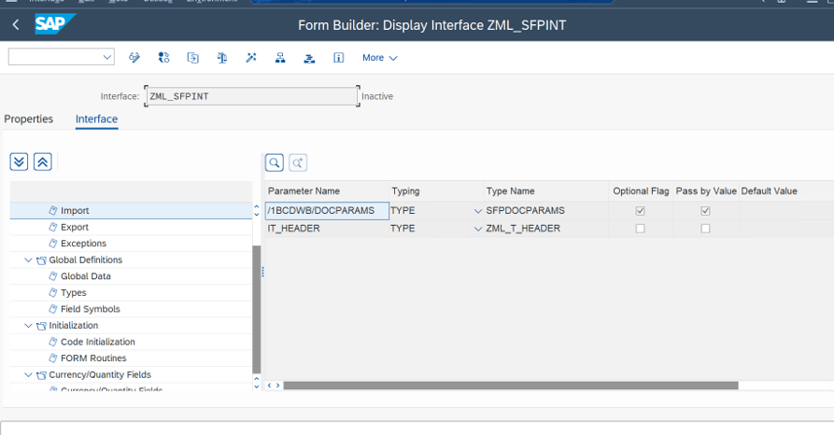

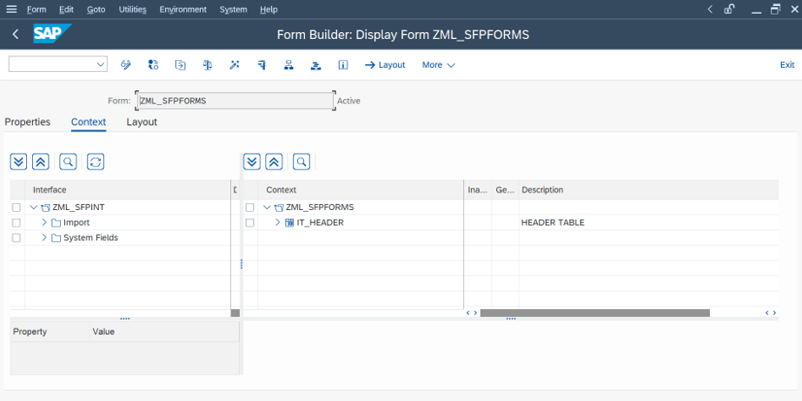

*\*&---------------------------------------------------------------------\**  
*\*& Report ZML_ADOBE_FORM*  
*\*&---------------------------------------------------------------------\**  
*\*&*  
*\*&---------------------------------------------------------------------\**  
REPORT ZML_ADOBE_FORM.  
  
DATA IT_DATA TYPE ZML_T_HEADER.  
  
DATA V_NAME TYPE FUNCNAME.  
DATA Z_NAME TYPE SFPOUTPUTPARAMS.  
  
SELECT VBELN FKDAT KUNRG FROM ZLOBO_1 INTO TABLE IT_DATA UP TO 10 ROWS.  
  
  
CALL FUNCTION 'FP_FUNCTION_MODULE_NAME'  
 EXPORTING  
 i_name = 'ZML_SFPFORMS'  
IMPORTING  
 E_FUNCNAME = V_NAME  
*\* E_INTERFACE_TYPE =*  
*\* EV_FUNCNAME_INBOUND =*  
 .  
  
CALL FUNCTION 'FP_JOB_OPEN'  
 CHANGING  
 ie_outputparams = Z_NAME  
*\* EXCEPTIONS*  
*\* CANCEL = 1*  
*\* USAGE_ERROR = 2*  
*\* SYSTEM_ERROR = 3*  
*\* INTERNAL_ERROR = 4*  
*\* OTHERS = 5*  
 .  
IF sy-subrc <> 0.  
*\* Implement suitable error handling here*  
ENDIF.  
  
CALL FUNCTION V_NAME  
EXPORTING  
 IT_HEADER = IT_DATA.  
  
CALL FUNCTION 'FP_JOB_CLOSE'  
*\* IMPORTING*  
*\* E_RESULT =*  
*\* EXCEPTIONS*  
*\* USAGE_ERROR = 1*  
*\* SYSTEM_ERROR = 2*  
*\* INTERNAL_ERROR = 3*  
*\* OTHERS = 4*  
 .  
IF sy-subrc <> 0.  
*\* Implement suitable error handling here*  
ENDIF.

